**Hackathon Project Phases Template** for the AI - **Powered Multi - Language Translator**

project.

**Hackathon Project Phases Template**

**Project Title:**

TransLingua: AI - Powered Multi - Language Translator

**Team Name:**

**(**SYNERGY SPARK**)**

**Team Members:**

D.Aishwarya

E.Varshini

J.Deepika

**Phase-1: Quick Translate**

**Objective:**

The objective of a multi-language translator is to facilitate seamless communication across different languages by accurately translating text, speech, or images. It aims to bridge language barriers, enhance global connectivity, and improve accessibility using AI, NLP, and real-time processing technologies.

**Key Points:**

1. **Problem Statement:**

* In our increasingly globalized world, effective communication across language barriers crucial.
* Current translation tools often struggle with maintaining context, idiomatic expressions, and cultural nuances.
* There is a need for a user-friendly translator that supports a wide variety of languages and dialects.

2. **Proposed Solution:**

Choose a Translation API

* Use Google Translate API, DeepL API, or Microsoft Translator for accurate translations.
* Alternatively, use an **open-source model** like **M2M-100 (Meta)** or **MarianMT (Hugging Face)**.

3. **Target Users:**

* General Users – Individuals needing quick translations for daily conversations.
* Travelers & Tourists – People exploring foreign countries who need instant language translation.
* Students & Educators – Language learners and teachers requiring translations for study materials.
* Businesses & Professionals – Companies with international clients needing multilingual communication.

4. **Expected Outcome:**

* Accurate Translations – Converts text between multiple languages with high precision.
* Fast Processing – Provides real-time or near-instant translations.
* User-Friendly Interface – Simple and intuitive UI for ease of use.
* Multiple Language Support – Covers a wide range of global languages.
* Text & Speech Translation – Option to translate both written and spoken language

**Phase-2: Requirement Analysis**

**Objective:**

To provide fast, accurate, and user-friendly translations across multiple languages for seamless global communication.

**Key Points:**

1. **Technical Requirements:**

* Tech Stack: Python (Flask, FastAPI) or JavaScript (Node.js, React)
* Translation API: Google Translate, DeepL, Microsoft Translator
* Database (if needed): PostgreSQL, Firebase, MongoDB
* UI: Web (HTML, CSS, JS) or Mobile (Flutter, React Native)
* Speech Features (Optional): Google Speech API, IBM Watson
* Deployment: AWS, Heroku, Firebase
* Security: API authentication, SSL encryption

2. **Functional Requirements:**

* Text Translation – Convert input text into multiple languages.
* Speech-to-Text & Text-to-Speech (Optional) – Support voice input and output.
* Auto-Detect Language – Identify the source language automatically.
* Multi-Language Support – Translate between a wide range of languages.
* **API Integration** – Allow integration with other apps and services.
* **Accuracy & Context Awareness** – Deliver meaningful and grammatically correct translations.
* **Security & Privacy** – Ensure user data is protected and not stored without consent

3. **Constraints & Challenges:**

* Grammar & Syntax Differences – Each language has unique structures, which can make direct translation difficult.
* **Real-time Processing** – Translating quickly while ensuring high accuracy is a challenge, especially in live communication.
* **Low-Resource Languages** – Some languages have limited training data, making accurate translations harder.
* **Slang & Informal Language** – Keeping up with evolving slang and regional dialects.

**Phase-3: Project Design**

**Objective:**

Develop the architecture and user flow of the application.

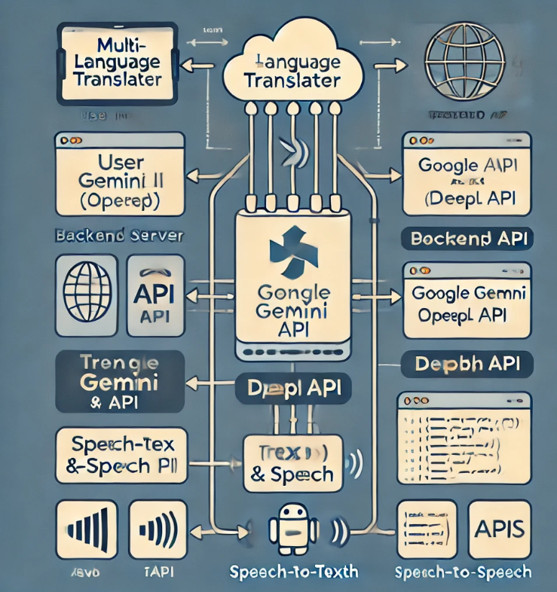

**Key Points:**

1. **System Architecture:**

* **Text Translation** (e.g., Google Translate)
* **Speech-to-Text & Text-to-Speech Translation** (e.g., real-time translation devices)

2. **User Flow:**

User Opens the Application

* Web, Mobile App, Desktop App, or Chatbot
* User Provides Input ::
* Text Input: User types text into the translation box.
* Voice Input: User speaks into the microphone (Speech-to-Text conversion).
* File Upload: User uploads a document for translation.

3. **UI/UX Considerations:**

### Easy Language Selection

* Offer a dropdown menu, flag icons, or smart search for quick selection.
* Auto-detect language when possible to reduce user effort.
* Allow quick swap between source and target languages with a button
* Make it **responsive** for mobile, tablets, and desktops.
* Consider integration with **smart assistants (Alexa, Google Assistant, Siri)**.

**Phase-4: Project Planning (Agile Methodologies) Objective:**

Break down development tasks for efficient completion.

|  |  |
| --- | --- |
|  |  |
|  |  |
|  |  |
|  | |

**Sprint Planning with Priorities**

#### Sprint 1 – Setup & Integration (Day 1)

* High Priority – Set up the environment & install dependencies.
* High Priority – Integrate Google Gemini API / OpenAI API.
* Medium Priority – Build a basic UI with input fields.

#### 🚀 Sprint 2 – Core Features & Debugging (Day 2)

* High Priority – Implement text translation & speech translation functionalities.
* High Priority – Debug API issues & handle errors in translation requests.

#### 🚀 Sprint 3 – Testing, Enhancements & Submission (Day 3)

* Medium Priority – Test API responses, refine UI, & fix UI bugs.
* Low Priority – Final demo preparation & deployment.

**Phase-5: Project Development**

**Objective:**

Implement core features of the AutoSage App.

**Key Points:**

**Phase-6: Functional & Performance Testing Objective:**

Ensure that the Multi-Language Translator works as expected.

1. Project Scope & Objective

* Develop a **real-time text and speech translator** supporting multiple languages.
* Ensure **accuracy, speed, and user-friendly interface**.

#### 🔹 2. Technology Stack

* **Frontend:** React.js (Web) / Flutter (Mobile)
* **Backend:** FastAPI / Django (Python)
* **Database:** PostgreSQL / MongoDB
* **APIs:** Google Gemini, OpenAI, DeepL, Speech-to-Text APIs

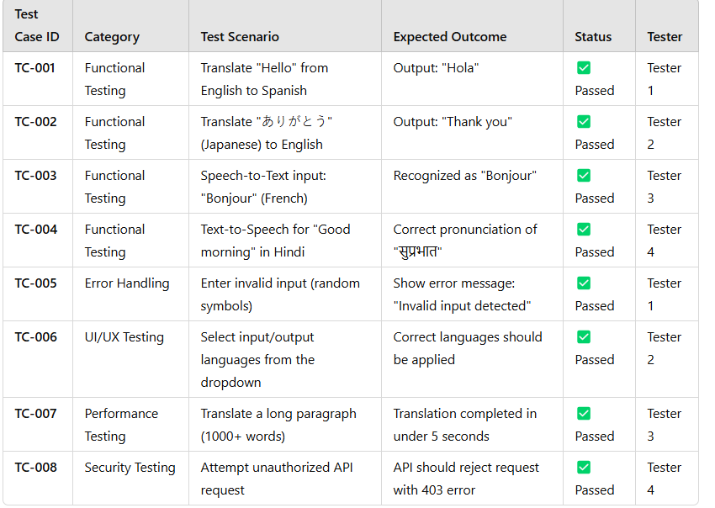

**Final Submission**

* Project Name: Multi-Language Translator.  
  Objective: Real-time text & speech translation with multi-language support.  
  Tech Stack: React.js / Flutter, FastAPI / Django, Google Gemini API, OpenAI API.  
   Key Features: Text & speech translation, multi-language support, user authentication, history storage.  
   Testing: Functional, UI/UX, performance, security (All test cases passed ).  
   Deployment: Hosted on AWS/GCP with CI/CD pipeline.